PROJECT DOCUMENTATION
Auto Ticket Classification using Flow Designer
ServiceNow System Administrator
Note on format: This document follows the standard 13-section project documentation format. The project is built on the ServiceNow platform (not MERN), so each section describes the ServiceNow equivalent: the ServiceNow form replaces the React frontend, Flow Designer replaces the Node.js / Express backend, and the ServiceNow table replaces MongoDB.

1. Introduction
Project Title: Auto Ticket Classification using Flow Designer
Course / Module: ServiceNow System Administrator
Team Members:
Name | Role
Pavithran B | Team Lead
Poovendhiran C R | Team Member
Rajasekara Babu | Team Member
Prabhakaran M | Team Member
Vishnu Priyan | Team Member

2. Project Overview

Purpose
The school IT helpdesk receives a high volume of daily support requests from students and faculty about network connectivity, hardware failures, account access issues and system performance. IT support staff were reviewing every ticket by hand to find the issue type, set the category and subcategory, and notify the caller. This was slow, prone to human error and hard to scale.
The goal of this project is to automate ticket classification and notification inside ServiceNow using Flow Designer, by analysing keywords in the incident description.

Features
- Automatic classification of incoming tickets based on the Short Description.
- Dynamic assignment of Category and Subcategory without manual staff intervention.
- Dependent choice filtering between Category and Subcategory.
- Automatic confirmation email to the caller as soon as the ticket is submitted.
- Custom Incident WorkFlow table with caller, state and assignment fields.
- All configuration tracked in a Project Update Set and exported to XML for deployment.

3. Architecture

Frontend (ServiceNow UI)
Instead of a React application, the user interface is the standard ServiceNow form of the custom table. The form was laid out in Form Design and shows Number, Caller, Category, Subcategory, Short Description, Description, State, Assigned group and Assigned to. The caller types the issue in the Short Description and the Category and Subcategory choice lists are filled in automatically. Subcategory choices are filtered by the selected Category.

Backend (Flow Designer and Platform)
Instead of Node.js and Express.js, the business logic runs on the ServiceNow platform through Flow Designer.
- Flow: Auto Classify School IT Tickets
- Trigger: Record Created, when Category is empty.
- Wi-Fi rule: Short Description contains 'Wi-Fi' or 'Network' sets Category = Network, Subcategory = Wi-Fi.
- Hardware rule: contains 'Projector' sets Category = Hardware, Subcategory = Projector.
- Access rule: contains 'Password' sets Category = Access, Subcategory = Forgot Password.
- Performance rule: contains 'Slow' sets Category = Performance, Subcategory = Slow Computer.
- Email action: sends 'Your Request for the issue has been submitted.' to the caller's email.

Database (ServiceNow Table)
Instead of MongoDB, data is stored in the custom table Incident WorkFlow (u_incident_workflow) in the Global application. The schema is:
Field | Type | Notes
Number | Auto Number | Unique ticket number, for example INC0001031
Caller | Reference (sys_user) | User who raised the ticket
Category | Choice | Network, Hardware, Access, Performance
Subcategory | Choice | Wi-Fi, Projector, Forgot Password, Slow Computer; dependent on Category
Short Description | String | Text analysed by the flow
Description | String | Full details of the issue
State | Choice | New (default), In progress, On hold, Resolved, Closed
Assigned group | Reference (sys_user_group) | Support group handling the ticket
Assigned to | Reference (sys_user) | Support staff member handling the ticket

Dependent choice mapping: Wi-Fi to Network, Projector to Hardware, Forgot Password to Access, Slow Computer to Performance. It is set with the 'Use dependent field' dictionary attribute on Subcategory, pointing to Category.

4. Setup Instructions

Prerequisites
- A ServiceNow instance (for example a Personal Developer Instance) with administrator access.
- A web browser (the screenshots in this report use Google Chrome).
- Email notifications working on the instance, so confirmation emails can be checked under System Logs > Emails.
- The exported Update Set XML file from this project (if importing instead of building from scratch).
No Node.js, MongoDB or environment variables are needed, because everything runs inside the ServiceNow instance.

Installation: Option A, import the Update Set
- Log in to the target instance as an administrator.
- Go to System Update Sets > Retrieved Update Sets and choose Import Update Set from XML.
- Select the exported Project Update Set XML file and upload it.
- Open the retrieved update set and click Preview Update Set. Fix any problems the preview reports.
- Click Commit Update Set to apply the table, fields, dependent choices and flow to the instance.
- Open Flow Designer and make sure the flow Auto Classify School IT Tickets is Active.

Installation: Option B, build from scratch
- Create a local Update Set named Project Update Set in the Global application, set the state to In progress and make it current.
- Create the custom table with the fields listed in the schema above.
- Add the Category and Subcategory choices, then enable 'Use dependent field' on Subcategory pointing to Category.
- In Flow Designer create the flow Auto Classify School IT Tickets with the Record Created trigger (Category is empty), the four keyword rules and the Send Email action.
- Activate the flow and test it (see section 10).

5. Folder Structure
A ServiceNow project has no client and server folders. The same split is shown below as components kept inside the Project Update Set.

Client side (what the user sees)
Component | Type | Purpose
Incident WorkFlow form | Form (Form Design) | Ticket entry screen with all fields
Category choice list | Choice field | Network, Hardware, Access, Performance
Subcategory choice list | Dependent choice field | Shows only choices that match the Category
Preview Email | Email record view | Shows the confirmation message sent to the caller

Server side (what runs on the platform)
Component | Type | Purpose
u_incident_workflow | Custom table (Table Designer) | Stores all tickets
Dictionary attributes | Field configuration | Dependent field setup on Subcategory
Auto Classify School IT Tickets | Flow (Flow Designer) | Keyword rules that set Category and Subcategory
Send Email action | Flow action | Confirmation email to the caller
Project Update Set | Update Set (Global) | Tracks every change; exported to XML

6. Running the Application
There are no npm commands. The application runs as soon as the Update Set is committed and the flow is active. To use it:
- Log in to the ServiceNow instance.
- Open the Incident WorkFlow form for a new record (u_incident_workflow.do).
- Choose the Caller, type the issue in the Short Description (for example 'Projector not turning on') and click Submit.
- Open the saved record and check that Category and Subcategory were filled in automatically.
- Check the confirmation email under System Logs > Emails and use Preview Email to read it.

7. API Documentation
No custom REST API was built in this project. The ticket form and the flow are used directly in the ServiceNow UI. ServiceNow does, however, give every table a built-in Table API, so the table can also be used from other applications if needed. The endpoints below are standard platform endpoints and were not part of the tested scope of this project.
Method | Endpoint | Purpose
GET | /api/now/table/u_incident_workflow | List tickets (supports query parameters such as sysparm_limit and sysparm_query)
GET | /api/now/table/u_incident_workflow/{sys_id} | Read one ticket
POST | /api/now/table/u_incident_workflow | Create a ticket (the flow runs on creation)
PATCH | /api/now/table/u_incident_workflow/{sys_id} | Update fields such as State or Assigned to

Example request (illustrative):
POST /api/now/table/u_incident_workflow
Content-Type: application/json

{ "short_description": "Projector not turning on" }
Example response (illustrative, shortened):
{ "result": {
"number": "INC0001033",
"short_description": "Projector not turning on",
"category": "hardware",
"subcategory": "projector",
"state": "new"
} }
The exact stored values of the choice fields depend on how the choices were defined in the table.

8. Authentication
- Login: Users sign in to the ServiceNow instance with their own credentials, and the platform keeps a session for them. No separate login code was written for this project.
- Authorization: Access to the custom table, forms and Flow Designer is controlled by ServiceNow roles and access controls. Configuration work (table, flow, Update Set) was done with an administrator account.
- Caller identity: The Caller field is a reference to the ServiceNow user record (sys_user), which is also where the caller's email address comes from for the confirmation email.
- Tokens: No custom tokens (such as JWT) are used. If the Table API is used, ServiceNow's built-in basic authentication or OAuth applies.

9. User Interface
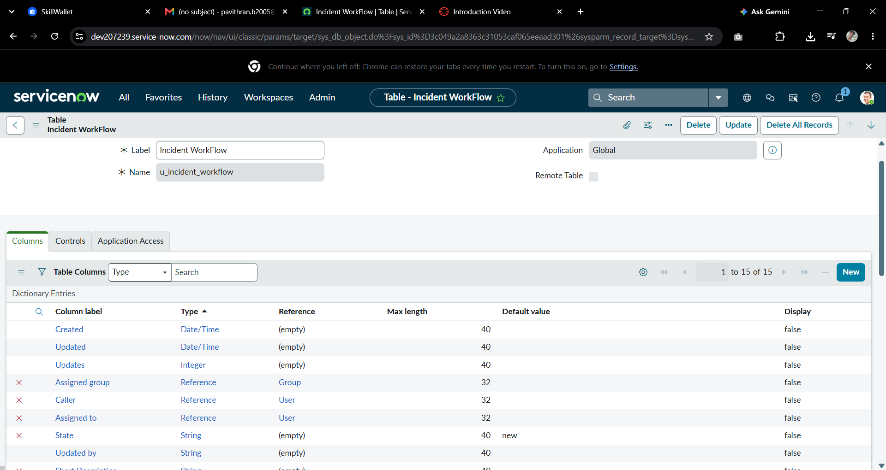
Figure 1: Custom table Incident WorkFlow (u_incident_workflow) and its columns
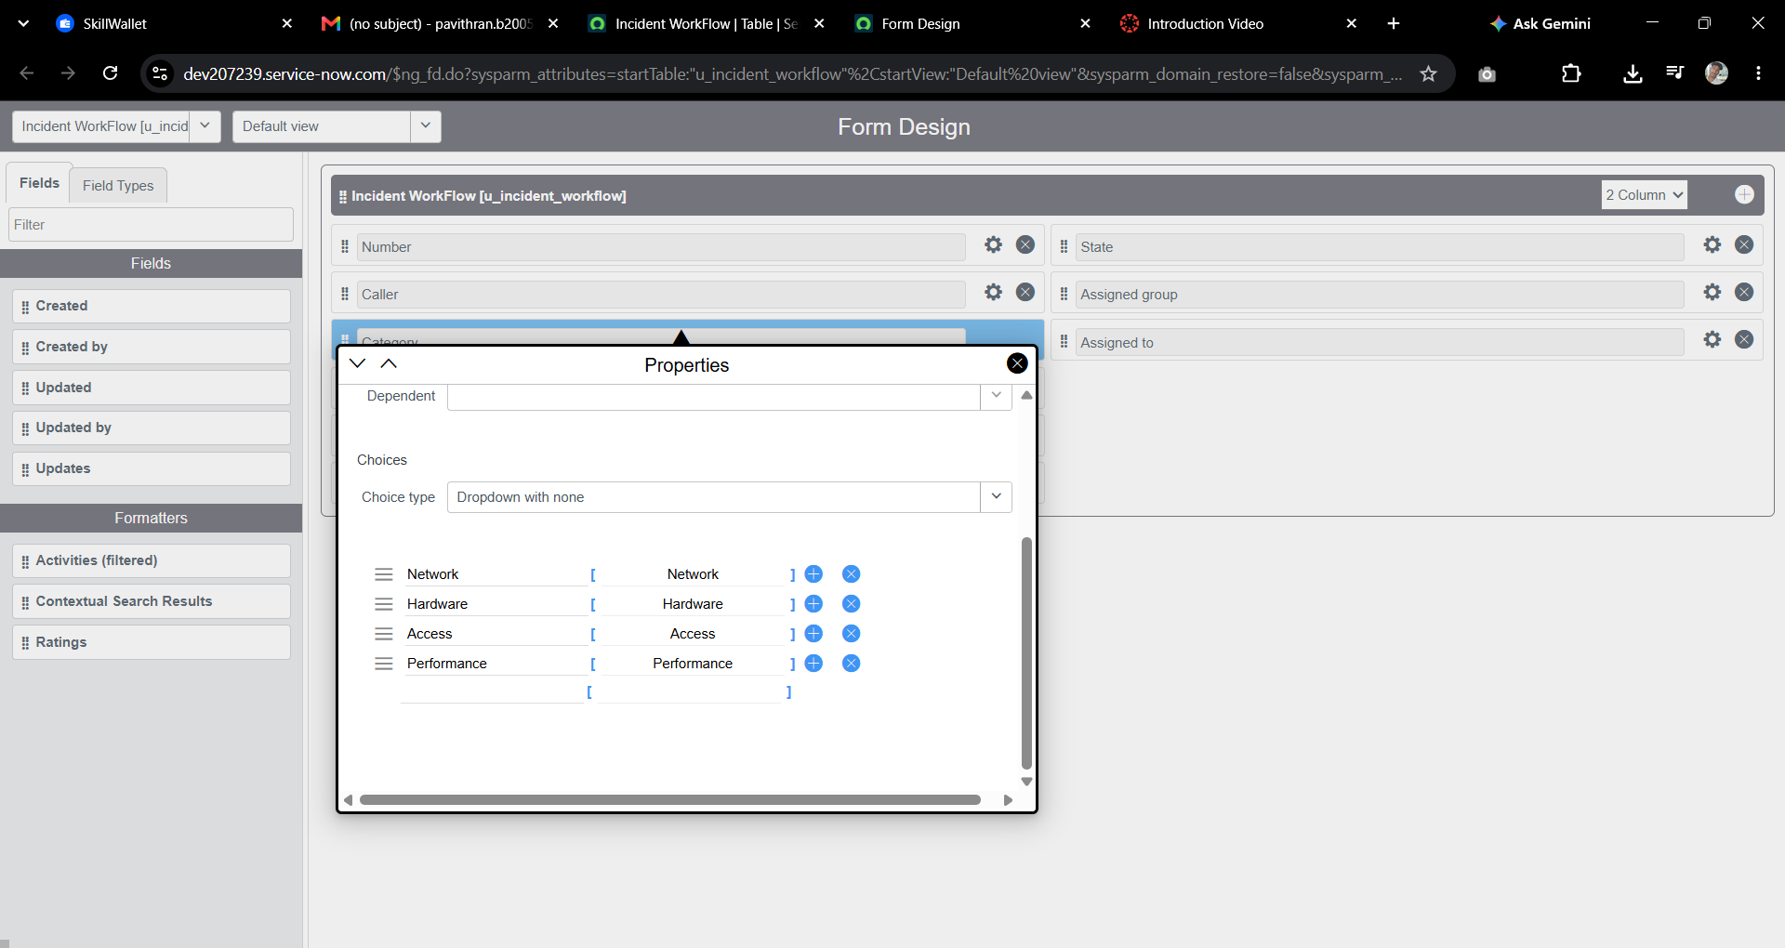
Figure 2: Form Design with the Category choices (Network, Hardware, Access, Performance)
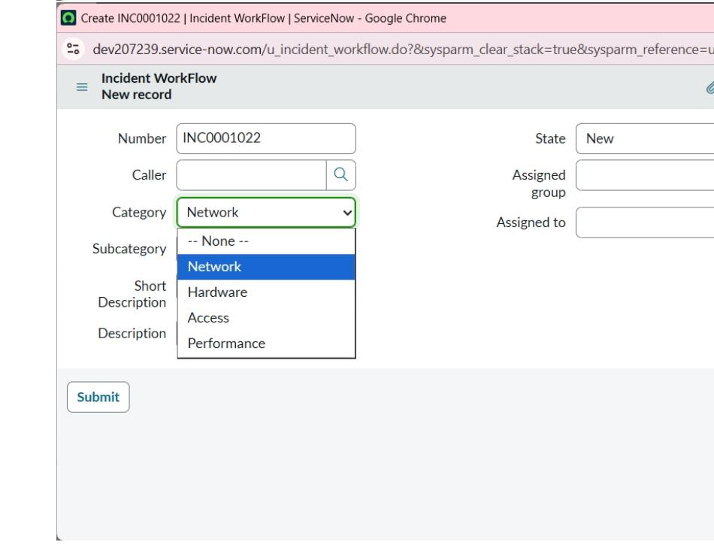
Figure 3: Category drop-down on the Incident WorkFlow form
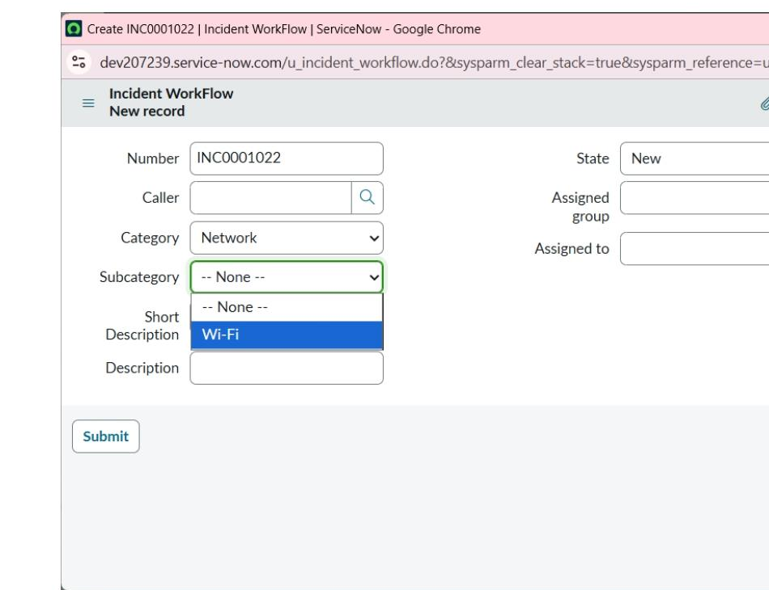
Figure 4: Subcategory drop-down filtered by Category (Network shows Wi-Fi)

10. Testing

Strategy and tools
Testing was done manually in the ServiceNow instance. A new ticket was created with a keyword in the Short Description, and the result was checked on the saved record. The email was checked in System Logs > Emails and with Preview Email. Update Set states were checked in Local Update Sets.

Test cases
No. | Input (Short Description) | Expected result | Result | Status
TC-1 | WiFi not working in library | Category = Network, Subcategory = Wi-Fi, confirmation email sent | Matched | Passed
TC-2 | (Email logs of TC-1) | Email appears under System Logs > Emails and the preview shows the message | Matched | Passed
TC-3 | Projector not turning on | Category = Hardware, Subcategory = Projector | Matched | Passed
TC-4 | Forgot my password | Category = Access, Subcategory = Forgot Password | Not recorded | Recommended
TC-5 | Computer is very slow | Category = Performance, Subcategory = Slow Computer | Not recorded | Recommended
TC-1 to TC-3 are the scenarios recorded in the project report. TC-4 and TC-5 cover the other two rules and are suggested so that all four rules have a recorded test.

11. Screenshots or Demo

Ticket classification output
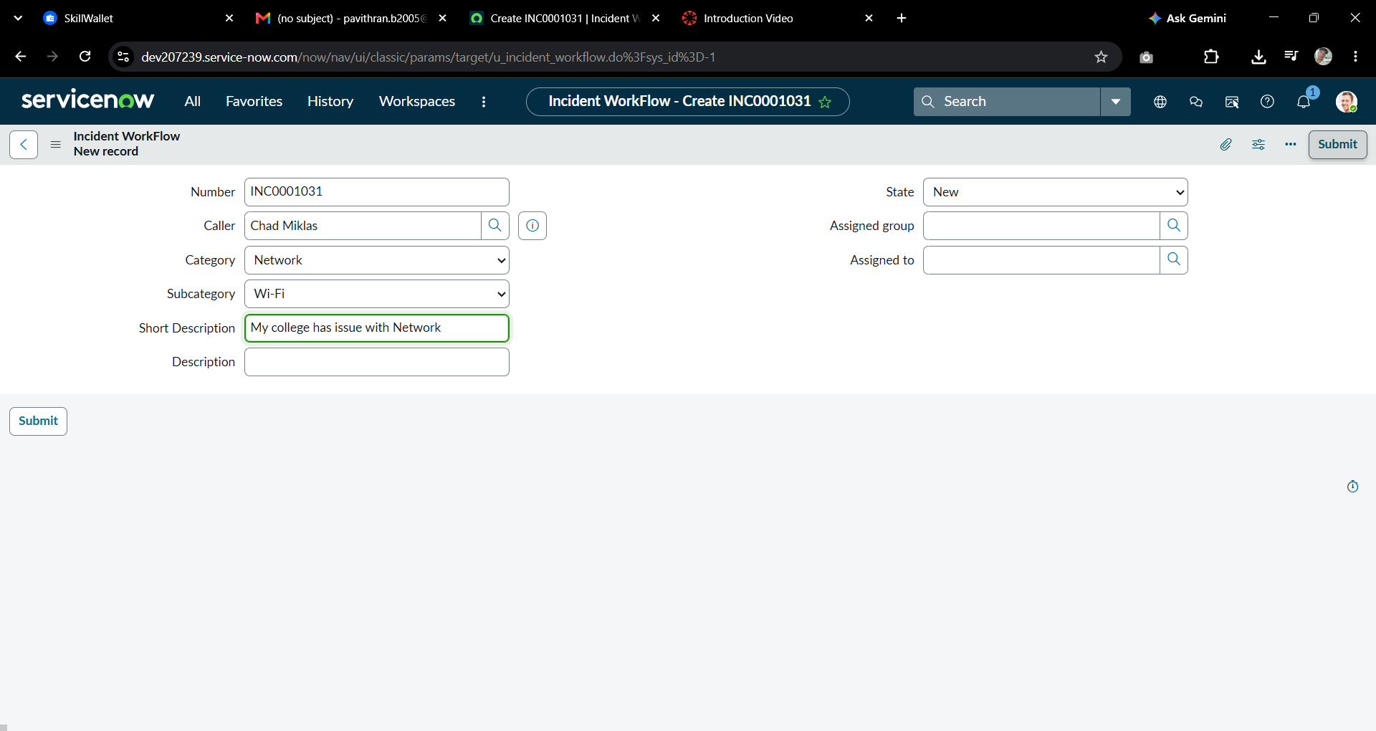
Figure 5: Ticket INC0001031 with Category = Network and Subcategory = Wi-Fi
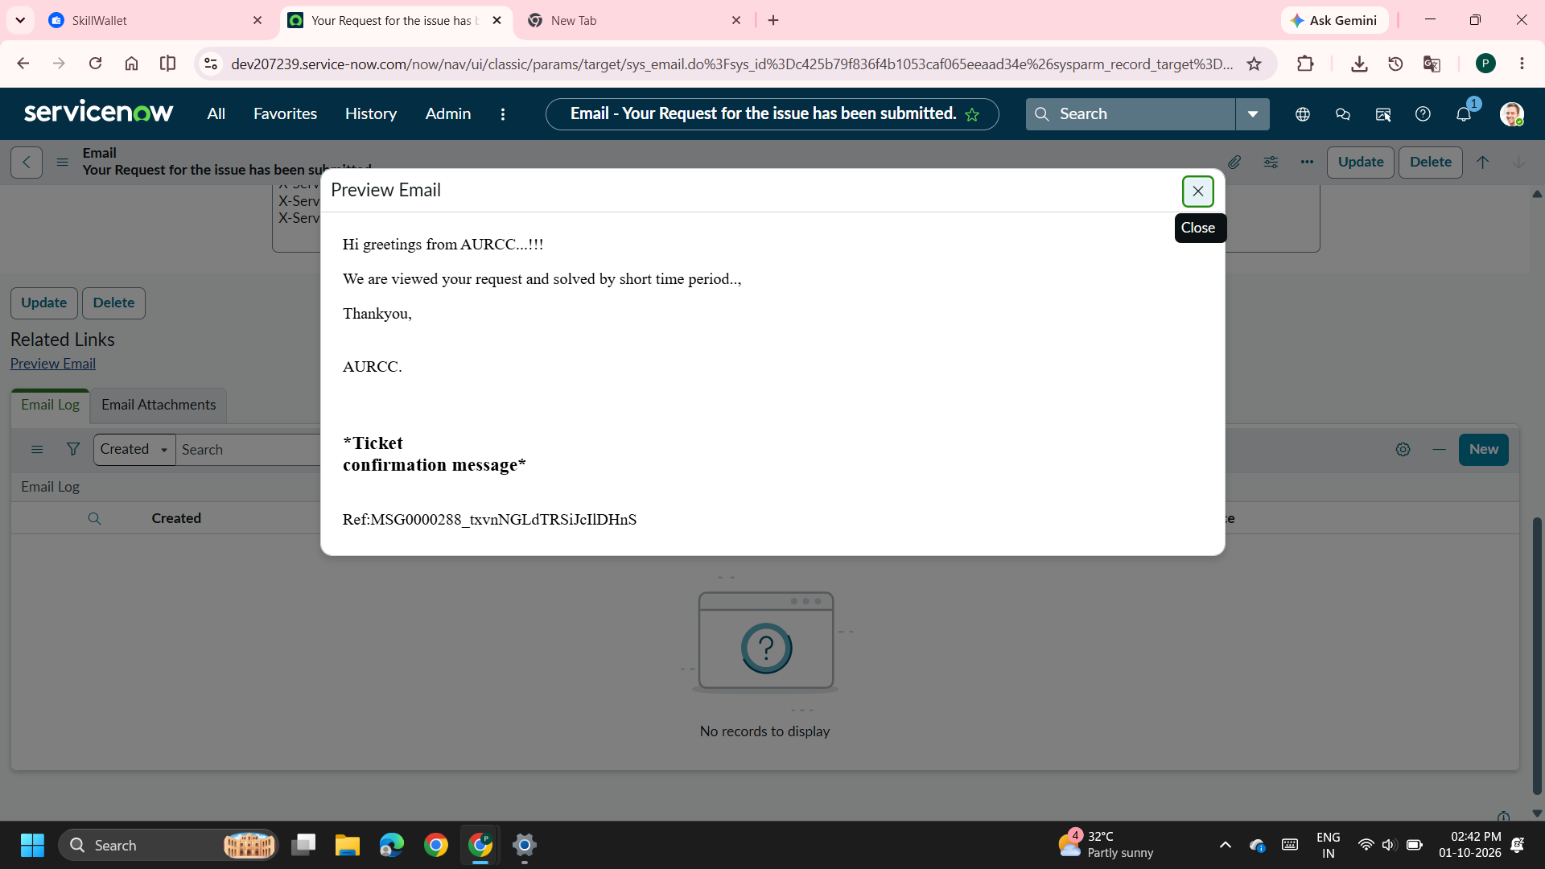
Figure 6: Preview of the confirmation email sent to the caller
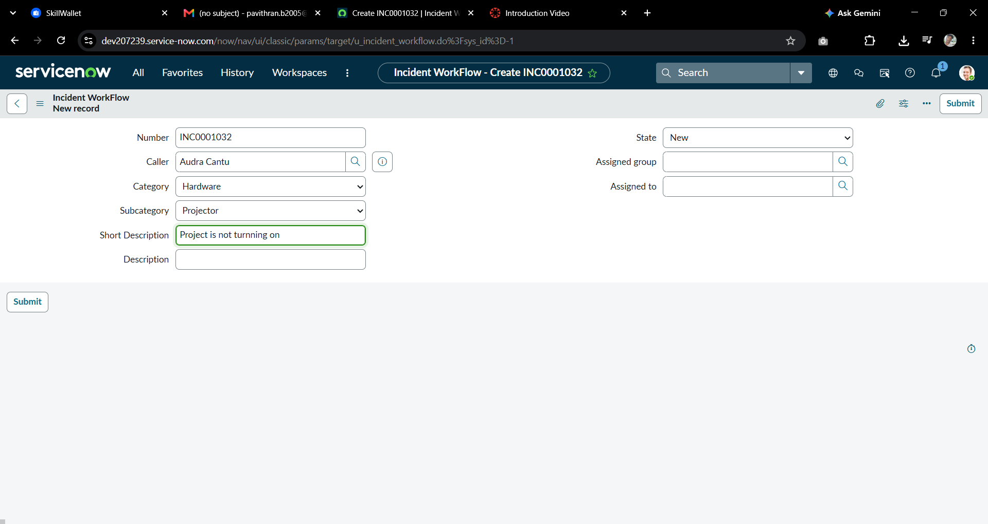
Figure 7: Ticket INC0001032 with Category = Hardware and Subcategory = Projector

Deployment (Update Set)
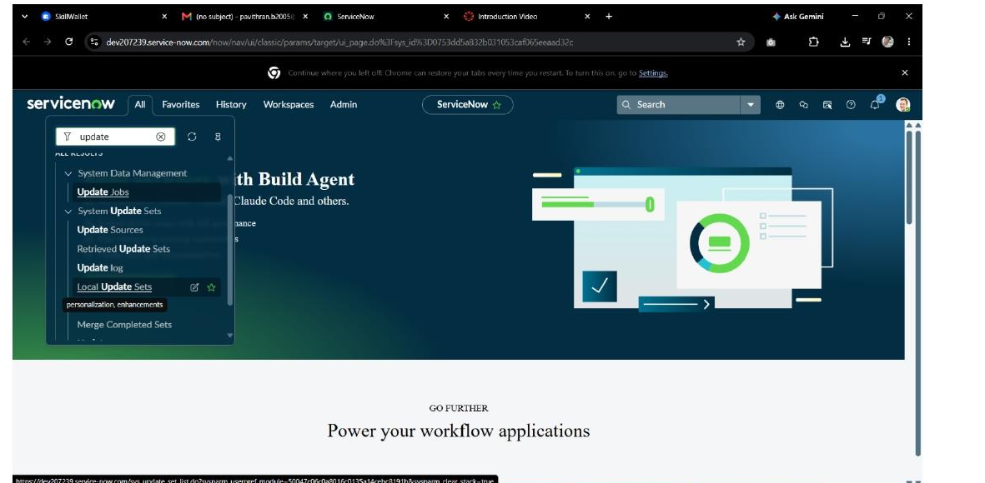
Figure 8: Navigating to Local Update Sets
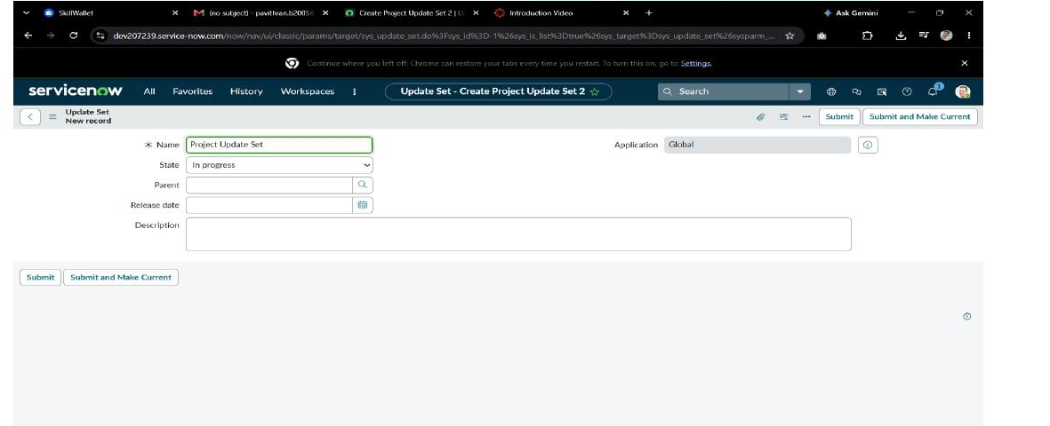
Figure 9: Creating Project Update Set (Global, In progress)
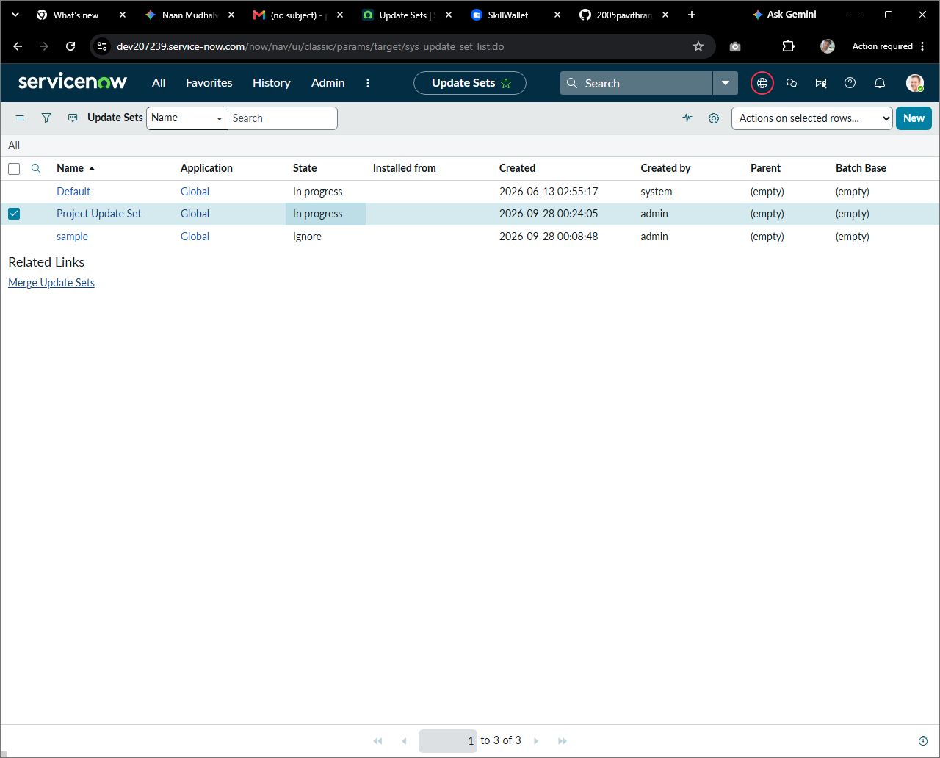
Figure 10: Project Update Set selected as current while In progress
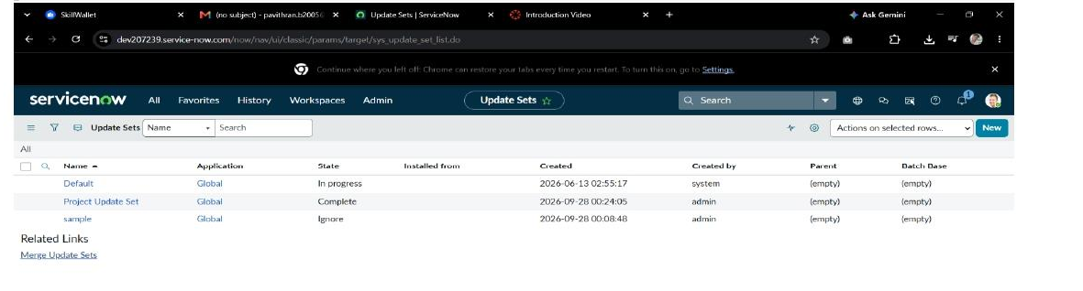
Figure 11: Project Update Set marked Complete, ready for XML export
Demo link: [Add demo video or link here if available]

12. Known Issues
These points come from reviewing the project design and test screenshots. They are limits to be aware of, not failures seen in the recorded tests.
- Keyword spelling: The Wi-Fi rule is written as 'Wi-Fi', while test TC-1 used 'WiFi' (no hyphen). Add every spelling users may type (Wi-Fi, WiFi, wifi) to the rule and confirm that matching ignores capital letters.
- No keyword, no category: A ticket with none of the four keywords keeps an empty Category and still needs manual triage.
- Several keywords in one ticket: If a Short Description contains more than one keyword (for example 'Slow Wi-Fi'), the result depends on the order of the rules.
- Only at creation: The flow runs only when a record is created with Category empty. Changing the Short Description later does not reclassify the ticket.
- Email depends on caller data: The confirmation email needs the caller to be selected and to have an email address on the user record.
- Email wording: The preview text ('We are viewed your request and solved by short time period') has grammar mistakes and should be reworded.

13. Future Enhancements
- Assignment automation: set Assigned group and Assigned to automatically from the Category.
- SLA tracking: add response and resolution targets for each category.
- Predictive Intelligence: use machine learning classification for tickets that do not contain a keyword.
- More categories and subcategories, with a keyword list that is easy to edit.
- Extra notifications: tell the assigned staff member and the caller when the State changes.
- Reports and dashboards showing tickets by category and resolution time.

